Weekly sponsor communication

|  |  |
| --- | --- |
| to: | Victor Nunez, Aesculap |
| from: | Cassie Christman |
| team name and Number: | Aesculap 1 |
| dates covered in this communication: | February 1, 2016 to February 7, 2016 |
| Week Number: | 1 of 15 |
|  |  |

**Introduction**

Our team would like to formally thank you for participating in Lehigh's University Technical Entrepreneurship and sponsoring a project. Our team is enthusiastic about your project and believe we can accomplish the goals you have set out for us.

Our team of six members consists of three bioengineering majors, two mechanical engineering majors and one supply chain major. Exhibit 1 displays our names, academic years, contact information and majors. Our detailed biographical sketches are in the Appendix.

|  |  |  |  |
| --- | --- | --- | --- |
| Christman, Cassie | Junior | clc217@lehigh.edu | BioEngr |
| Davis, Christian | Junior | ctd217@lehigh.edu | ME |
| Haupt, Alexis | Junior | anh217@lehigh.edu | BioEngr |
| Loughran, Brian | Junior | btl217@lehigh.edu | ME |
| Obzud, Cassie | Senior | cpo216@lehigh.edu | SupChMgt |
| Sargeant, Jadon | Junior | jts317@lehigh.edu | BioEngr |

Exhibit 1 Team Contact Information

**Overview**

For clarification, the sponsor communication brief will be emailed to you on a weekly basis every Friday by 12:00 noon. The brief will consist of the progress of our work from the previous week (Monday-Sunday).

For the semester we have assigned team roles based on the strengths of our team members. Brian Loughran, our team liason, will be your primary contact for communication between our team and you. He can be reached by email at btl217@lehigh.edu, or by phone at 201-317-3254.

In lecture and through class readings, we are learning about the Technical Entrepreneurship process and will be applying that knowledge to our project. This process is shown in Exhibit 2. I thought it would be helpful for you to see what we will be abiding by as our conceptual design process. The yellow-orange shaded boxes are the steps we will have completed by the end of this semester, and the white boxes are what we will be focusing on the following semester. As of this week, we are creating our mission statement and determining the customer needs.

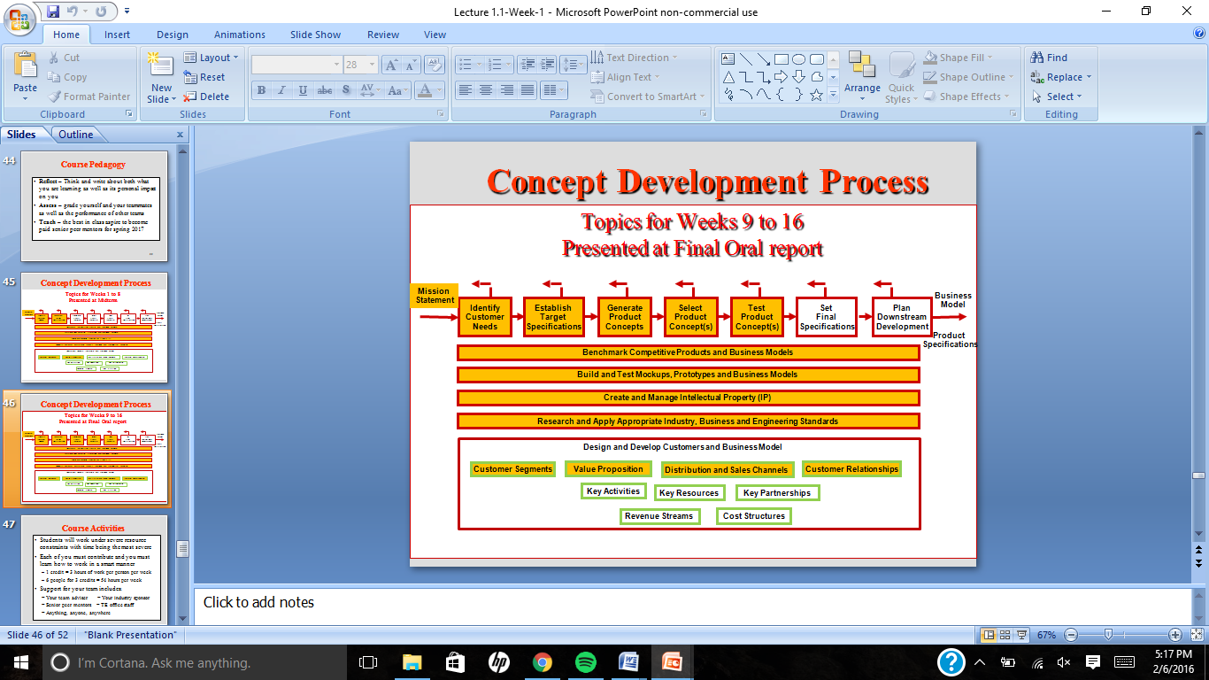



Exhibit 2 The Conceptual Development Process in TE

**Accomplishments**

1. We researched Aesculap through both the B.Braun and Aesculap websites to gain basic knowledge on the values of Aesculap and the products currently offered by Aesculap.
2. In lecture, we learned the basics of the product development process and patents, which is information we will apply throughout this project.

**Next Steps**

1. On Wednesday February 10th, our team will visit Aesculap and meet with you to discuss the project.
2. We will develop our mission statement and begin identifying customer needs.

**Proposed Communication Expectations**

1. We would greatly appreciate a confirmation email verifying you received our weekly brief.
2. We would also appreciate you responding to our issues and questions stated in the weekly brief by the subsequent Tuesday with any information you can provide us with.

**Appendix: Team BioSketches**

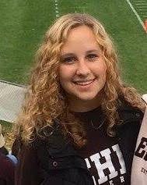

## Cassie Christman

4 Farrington Square

Box 6484

Lehigh University

Bethlehem, PA 18015

Phone: (610) 790-3201 E-mail: clc217@lehigh.edu

**Education**

* B.S., Bioengineering 2017
* Minor in Economics

**Leadership**

* Sisterhood Chair for Kappa Delta Sorority
* Biomedical Engineering Society mentor
* Residential Studying and Tutoring program Physics Tutor

**Special Skills**

* AutoCAD
* Microsoft Office
* Atomic force spectroscopy, nanoindenting and imaging

**Work Experience** (in reverse chronological order)

* October 2015 to present, Lehigh University, undergraduate research assistant
* Fall 2014 to present, Lehigh University, tutor for physics
* Spring 2013 to December 2015, Best Buy, sales consultant

**Personal Narrative:**

Cassie Christman began at Lehigh in August 2013 pursuing the biomechanics and biomaterials track of Bioengineering. In transitioning from high school to college, Cassie has sustained her interests outside of bioengineering by being involved in a variety of organizations including the Society of Women Engineers, the LU Club Field Hockey Team, the Biomedical Engineering Society, and the Kappa Delta Sorority. Within the Biomedical Engineering Society, Cassie enjoys the role as a mentor in which she advises first-year Bioengineering students. In Kappa Delta, Cassie served as the chapter's Sisterhood Chair in which she organized a minimum of three events per month to strengthen the bonds between the sorority's members while maintaining an established semesterly budget. Cassie also currently conducts research in Dr. Xiaohui Zhang's lab at Lehigh University in which she is using Atomic Force Spectroscopy to test the elasticities of certain lines of cancer cells. Through this research Cassie has developed basic cell cultures skills and has learned how to nanoindent and image cells using an atomic force microscope. Through IPD, Cassie hopes to apply many of the skills she has learned in class and through her research to a real-world scenario, as well as gain more experience as both a leader and an active group member.

Christian Davis

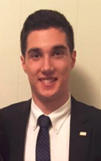4 Campus Square 6330

Bethlehem, PA 18015

Phone: (603) 953-4417           E-mail: ctd217@lehigh.edu

**Education**

* B.S. in Mechanical Engineering, 2017
* Minor in Energy Engineering
* Minor in Economics

**Leadership**

* Fundraising Chair - Engineers Without Borders

**Special Skills**

* CAD Modeling (SolidWorks, NX 8.5)
* Microsoft Office
* MATLAB
* Tensile/Torsion Testing Machines
* 3D Printing
* Patent Analysis

**Work Experience**

* Fall 2015 to Present, R&D Engineering Co-Op at B. Braun Medical
* Summer 2009 to Present, Bagger/Cashier at Market Basket Supermarkets
* Summer 2012, Maintenance Worker at Davis Court Apartments

**Personal Narrative:**

As a part of Lehigh University's Engineering Co-Op program, Christian Davis worked full time in Fall 2015 as a member of B. Braun's Innovations and R&D department.  Through this experience Christian applied the engineering knowledge he learned in school to run mechanical tests on medical devices, analyze outcomes, and present findings to coworkers.  For the past seven years Christian has always worked as a cashier/bagger at his hometown grocery store in New Hampshire.  Additionally, as the Fundraising Chair for Lehigh's chapter of Engineering Without Borders, Christian has helped to fund the clubs operations and trips to Nicaragua through a combination of grant-writing, club events, and crowd-funding.  In his free time, Christian enjoys exercising and is a brother of Sigma Phi Epsilon at Lehigh University.  Christian hopes to use the IPD process as a way to apply his mechanical engineering knowledge in a real-world setting and increase his marketability when applying to graduate school.

Alexis Haupt

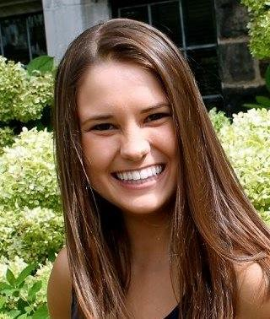4 Farrington Square

Box 3742

Lehigh University

Bethlehem, PA 18015

Phone: (570) 956-5826           E-mail: [anh217@lehigh.edu](mailto:anh217@lehigh.edu)

**Education**

* B.S., Bioengineering 2017

**Leadership**

* Think Pink Chairman for Zeta Tau Alpha
* Special Events Chairman for Zeta Tau Alpha

**Special Skills**

* MATLAB
* Arduino

**Work Experience**

* June 2014 to Aug 2014, Precision Design, Data Entry Clerk

**Personal Narrative:**

Alexis Haupt is currently studying bioengineering at Lehigh University. She has participated in many research projects and competitions such as PJAS during her high school career, where she became interested in pursuing a career in research. With robotics and engineering classes both before and during her time at Lehigh, she has been able to gain experience working with multiple types of programs and different coding languages, such as Java, C, and C++. She also has had two positions within her sorority chapter, both of which have helped her learn to be able to organize, plan, and communicate efficiently with other people, including companies to sponsor or donate to the events. By taking this IPD course, Alexis hopes to be able to improve her group work skills and to learn new ideas and ways of thinking from her project group, mentors, and sponsor.

## Brian LoughranBrian Loughran

4 Campus Square

Box 4428

Lehigh University

Bethlehem, PA 18015

Phone : (201)-317-3254         E-mail: [btl217@lehigh.edu](mailto:btl217@lehigh.edu)

**Education**

* B.S., Mechanical Engineering 2017
* Minor in Aerospace Engineering
* Minor in Business

**Leadership**

* Treasurer Club Hockey Team
* Scholarship Chair, Kappa Sigma

**Special Skills**

* C++, Java, Python
* MATLAB, Arduino, LabVIEW
* NX Cast, SolidWorks, Pro/Engineer

**Work Experience** (in reverse chronological order)

* June 2015 to Aug 2015: Mechanical Engineering Intern at Alcatel-Lucent Bell Labs
* August 2014 to December 2014: Teacher’s Assistant for Applied Engineering Computer Methods
* June 2012 to August 2014: Inventory Management at Quaker Pet Group

**Personal Narrative:**

Brian Loughran enrolled at Lehigh University in 2013 as a mechanical engineering student. Last summer he worked at Alcatel-Lucent, a communications company, at Bell Labs on several different projects within the mechanical engineering industry. Thermal testing was conducted on 4G LTE and eventual 5G controllers to ensure that they would be able to withstand the extreme hot and cold external temperatures. A wind tunnel was designed and fabricated to thoroughly characterize flow dynamics over the components and to understand cooling fan performance. Acoustic testing was conducted in a fully anechoic chamber to characterize cooling fan noise levels. On top of this experience, he was voted treasurer of the club hockey team. Responsibilities for this position include collection, budgeting and management of over 80,000 in team funds. In taking IPD, Brian hopes to gain experience with team based research as well as real world working experience on a challenging project as he prepares for a job in the mechanical engineering industry.

## Macintosh HD:Users:CassieObzud:Desktop:unnamed.jpgCassie Obzud

506 Thomas Street

Bethlehem, PA 18015

Phone: (914) 715-8392           E-mail: cpo216@lehigh.edu

**Education**

* B.S., Supply Chain Management, 2016

**Leadership**

* Supply Chain Management Major Rep on the CBE Student Board of Advisors, Lehigh University
* Secretary & Warden, Alpha Chi Omega Sorority, Lehigh University

**Special Skills**

* Microsoft Office

**Work Experience**

* June 2015 to Aug 2015, Transfix, Supply Chain Business Intern
* June 2014 to Aug 2014, Almar Sales, Merchandising Intern
* June 2011 to Aug 2012, Consider the Cook, Salesperson

**Personal Narrative:**

Cassie Obzud enrolled at Lehigh University in 2012 as a Supply Chain Management student. She worked as the Supply Chain Business intern for a technology startup, Transfix, during the summer of 2015 where she collaborated with sales, marketing, and IT developers to help improve operational efficiency. During the summer prior, she served as a Merchandising intern at a fashion sales company. During her sophomore year she was nominated as the Supply Chain Management Major Representative on the Student Board of Advisors where she assists in meetings regarding issues within the College of Business and Economics. She gained leadership experience while serving as the Secretary and Warden to her sorority, Alpha Chi Omega. Last semester, she studied abroad in Rome, Italy. In taking IPD, Cassie hopes to gain experience in developing engineering design solutions and team research that can be applied after she graduates.

## https://lh6.googleusercontent.com/_cQInsiaUUC-qu-DQZWrhwpWIaSMCkVOENR4wWUce2737EopveBZyehkBHTpjM1OIAAFCFeQvrtGBC5on3wiS_koDUz4WoAn-4GlBSmb1xABXXFcZCJsejddYrPm6-X3xpHZVp1mumg2e-lDJadon Sargeant

4 Campus Square

Box 2617

Bethlehem, PA 18015

Phone: 610-348-2841           E-mail: jts317@lehigh.edu

**Education**

* B.S., Bioengineering, 2017
* Minor in Business

**Leadership**

* Assistant captain of Lehigh Ultimate Frisbee Team
* Founding Vice President of Lehigh Disc Golf Club
* Certified rescue diver
* Eagle scout

**Special Skills**

* Solid Works/Edge, Microsoft office, MatLab
* Water jet, operate workshop equipment
* Microscopy and imaging, cell and tissue culture
* Pressure vessel design and computer simulation

**Work Experience**

* Aug 2015 to Jan 2016, Musculoskeletal Transplant Foundation R&D Co-op
* May 2015 to Aug 2015, Lehigh University BDSI Research assistant
* May 2014 to Aug 2014, Operation Wallacea Research Fellow
* May 2013 to Aug 2013, Climbing Instructor Camp Ockanickon

**Personal Narrative:**

The summer after Jadon’s first year at Lehigh, he flew to Honduras to work as a research fellow for Operation Wallacea, a conservational research organization. While there, he tracked carbon content in the mountainous forests using GIS software, this data is used in the international carbon emissions market. Jadon Sargeant took a leave of absence from Lehigh this past fall to work as an R&D engineer at the Musculoskeletal transplant Foundation (MTF), the world’s largest tissue engineering company. During his time there he was granted a provisional patent for developing an innovative cartilage harvesting technique. This summer he was given an HHMI grant to work for Lehigh’s BDSI program. His research focused on the biomechanics of cerebral aneurysms. The Mechanical Engineering department has agreed to fund the continuation of this research through the spring. He will present findings at a conference this spring for the American Institute of Aeronautics and Astronautics. In his free time he founded the Lehigh University Disc Golf Club and plays ultimate frisbee. He hopes to gain experience working with artificial materials and combine this with his exposure to allograft technology. After graduation he will either join the R&D department of an orthopedic implant company or continue his research in a graduate program.